

Machine Learning-Music Recommendation

Progress Report

| Roll No. | Name of the Student | Name of the Program |
| --- | --- | --- |
| AU1940142 | Shail | ML |
| AU1940267 | Sahil | ML |
| AU1940034 | Varun | ML |

**Data received from spotify api**

We successfully created a service that retrieves the top 50 songs of the user that he has been listening to in the past 6 months. The data is then downloaded in a csv format along with the artist name, song name, duration listened etc.

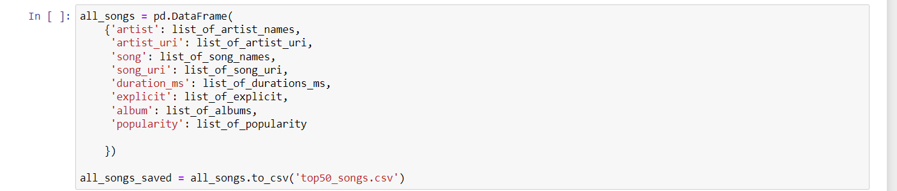

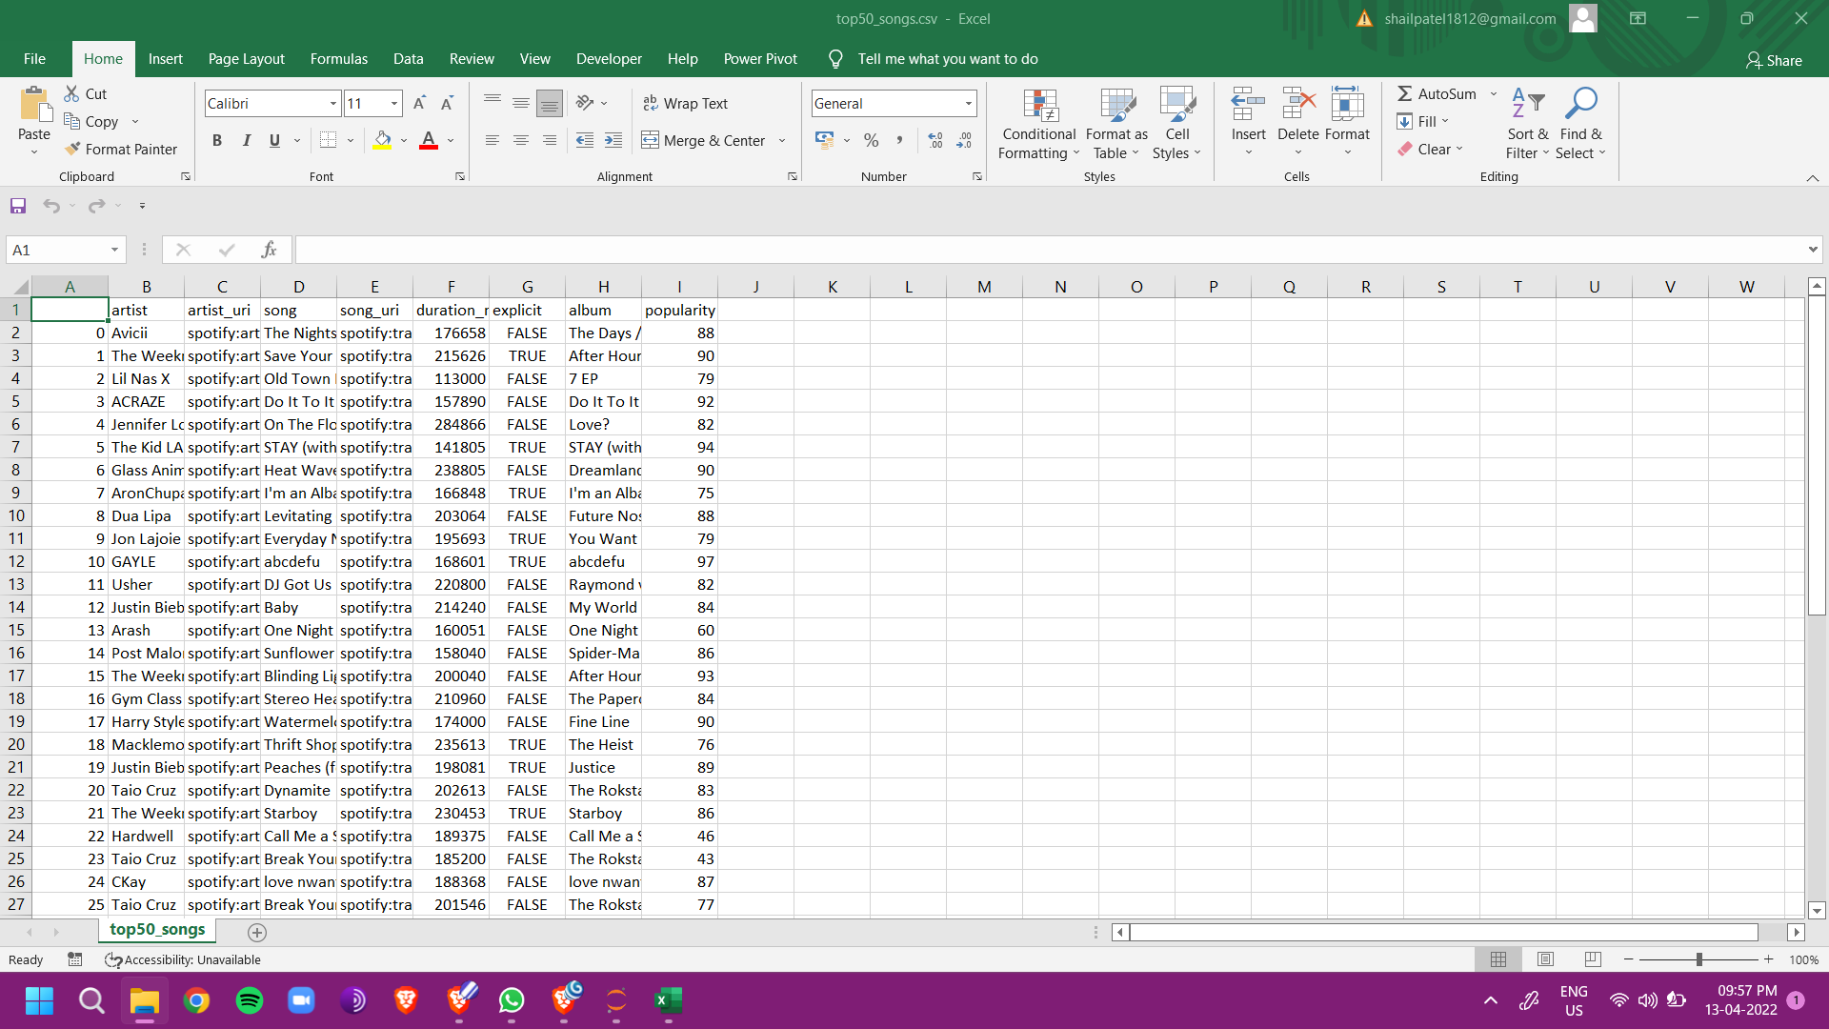

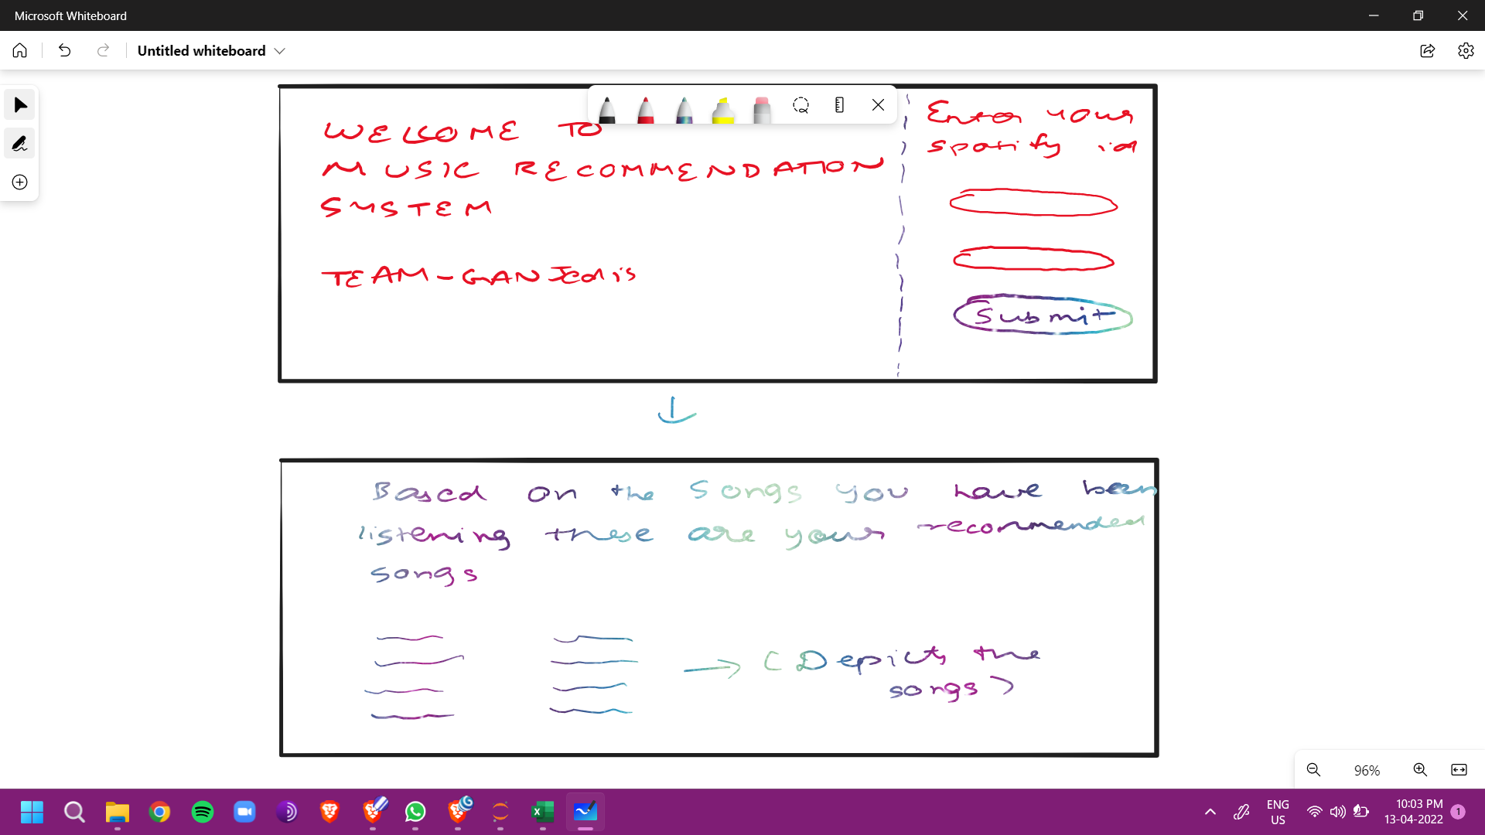

Depicts the basic UI we will be creating to deliver the end product to the user.

**Future work**

Creating a link between the UI design and the backend code and getting output visible to the end user.